**1.Fix the bugs in below snippet**

<html lang="en">   
 <head>   
 <title>Document   
 <body>   
 guvi   
 </title>   
 </head>   
 <div>   
 Lorem ipsum dolor sit amet consectetur adipisicing elit.

<div>   
 <div>   
 Guvi Geek Network   
 </div>   
 </body>   
 </html>   
solution:   
<!doctype=”html”>   
<html lang="en">   
 <head>   
 <title>Document</title>   
 </head>   
 <body>   
 guvi   
 <div>   
 Lorem ipsum dolor sit amet consectetur adipisicing elit.

<div>   
 <div>   
 Guvi Geek Network   
 </div>   
 </body>   
</html>

**2.Try the below one**

<html lang="en">

<head>

<title>Document

<body>

guvi

</head>

<div>

Lorem ipsum dolor sit amet consectetur adipisicing elit.

<div>

<div>

Guvi Geek Network

</div>

</body>

</html>

solution:

<html>

<html lang="en">

<head>

<title>Document</title>

</head>

<body>

guvi

<div>

Lorem ipsum dolor sit amet consectetur adipisicing elit.

</div>

<div>

Guvi Geek Network

</div>

</body>

</html>

**3.Design a contact us form with all fields as required.**

<!DOCTYPE html>

<html lang="en">

<head>

<meta charset="UTF-8">

<meta http-equiv="X-UA-Compatible" content="IE=edge">

<meta name="viewport" content="width=device-width, initial

-scale=1.0">

<title>contact FORM</title>

<style>

fieldset{

border: 0px;

width: 30px;

}

div{

text-align: center;

font-size: 25px;

font-family: cursive;

color: pink;

}

p{

text-align: center;

font-weight: bolder;

font-size: 20px;

}

input{

border-radius: 7px;

border-width: 1px;

height: 30px;

}

.btn{

text-align: center;

font-size: 20px;

font-family: -apple-system, BlinkMacSystemFont, 'S

egoe UI', Roboto, Oxygen, Ubuntu, Cantarell, 'Open Sans', 'Hel

vetica Neue', sans-serif;

background-color: spring green;

width: 450px;

height: 35px;

}

</style>

</head>

<body>

<form>

<fieldset>

<div><h1>CONTACT FORM</h1></div>

<h2>Customer Contact Form</h2>

<table>

<tr>

<td colspan="2">

<label for="Fname">F Name</label><br>

<input type="tel" id="Fname" name="Fname" size

="60px" placeholder="Fname" required>

</td>

</tr>

<tr>

<td colspan="2">

<label for="Lname">L Name</label><br>

<input type="tel" id="Lname" name="lname" size

="60px" placeholder="Lname" required>

</td>

</tr>

<tr>

<td colspan="2">

<label for="email">EMAIL ID</label><br>

<input type="tel" id="email" name="Email" size

="60px" placeholder="Email Id" required>

</td>

</tr>

<tr>

<td colspan="2">

<label for="phone">PHONE NO</label><br>

<input type="tel" id="phone" name="phone" size

="60px" placeholder="Phone no" required>

</td>

</tr>

<tr>

<td colspan="2">

<label for="adress">Address</label><br>

<input type="tel" id="query" name="query" size

="60px" placeholder="Adress" required>

</td>

</tr>

<tr>

<td colspan="2">

<label for="city">City</label><br>

<input type="tel" id="city" name="city" size

="60px" placeholder="city" required>

</td>

</tr>

<tr>

<td colspan="2">

<label for="message">Message</label><br>

|  |  |  |  |  |
| --- | --- | --- | --- | --- |
| <input | type="tel" | id="msg" | name="message" | size="60px" |
| placeholder="Message" required> | | |

</td>

</tr>

<tr>

<td colspan="2">

<br>

<button class="btn"id="submit">Contact Us</button

ton>

</td>

</tr>

</table>

</fieldset>

</form>

</body>

</html>

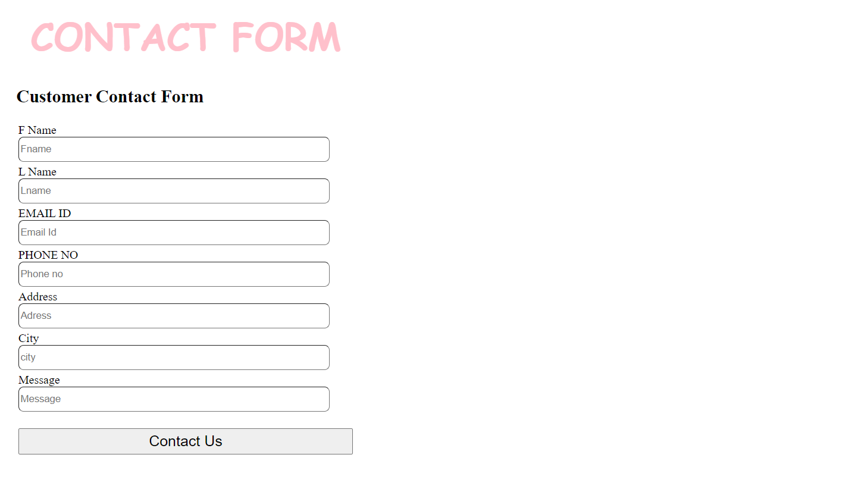

**4.Use certain HTML elements to display the following in a HTML page.**

Programming Language

JavaScript

Angular

React

Vue.js

Python

Django Framework

Flask Framework

Java

Spring

Maven

Hibernate

Database

MySQL

MongoDB

Cansandra

solution:

<!DOCTYPE html>

<html lang="en">

<head>

<meta charset="UTF-8">

<meta http-equiv="X-UA-Compatible" content="IE=edge">

<meta name="viewport" content="width=device-width, initial

-scale=1.0">

<title>Document</title>

</head>

<body>

<p>

<ul>

<li>Programming Language</li>

<ul>

<li>JavaScript</li>

<ol type="a">

<li>Angular</li>

<li>React</li>

<li>Vue.js</li>

</ol>

<li>Python</li>

<ol type="a">

<li>Django Framework</li>

<li>Flask Framework</li>

</ol>

<li>Java</li>

<ol type="a">

<li>Spring</li>

<li>Maven</li>

<li>Hibernate</li>

</ol>

</ul>

<li>Database</li>

<ul>

<li>MySQL</li>

<li>MongoDB</li>

<li>Cansandra</li>

</ul>

</ul>

</p>

</body>

</html>

Output:

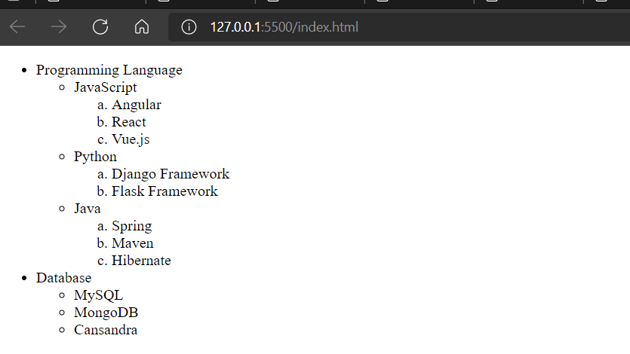

**5.Create an element that helps you to open the https://google.com in separate new tab.**

<!doctype html>

<html lang="en">

<head>

<title>How to Open Link in New Tab or Window</title>

<style>

body{

padding:15px;

font-size: 20px;

}

</style>

</head>

<body>

<h2>An element that helps you to open the https://google.com in

separate new tab </h2><br><br>

<a href="https://www.google.com/" target="_blank" rel="noopener noreferrer">How to search in browser </a>

</body>

</html>

**6.In the form, add two radio buttons with grouping them for employee type(Salaried and own business)**

<!DOCTYPE html>

<html lang="en">

<head>

<meta charset="UTF-8">

<meta http-equiv="X-UA-Compatible" content="IE=edge">

<meta name="viewport" content="width=device-width, initialscale=1.0">

<title>Document</title>

</head>

<body>

<fieldset>

<legend>Employee Type</legend>

<div>

<input type="radio" name="format" id="txt" value="txt" checked>

<label for="txt">salarified</label>

</div>

<div>

<input type="radio" name="format" id="csv" value="csv">

<label for="csv">OwnBusiness</label>

</div>

</fieldset>

</body>

</html>

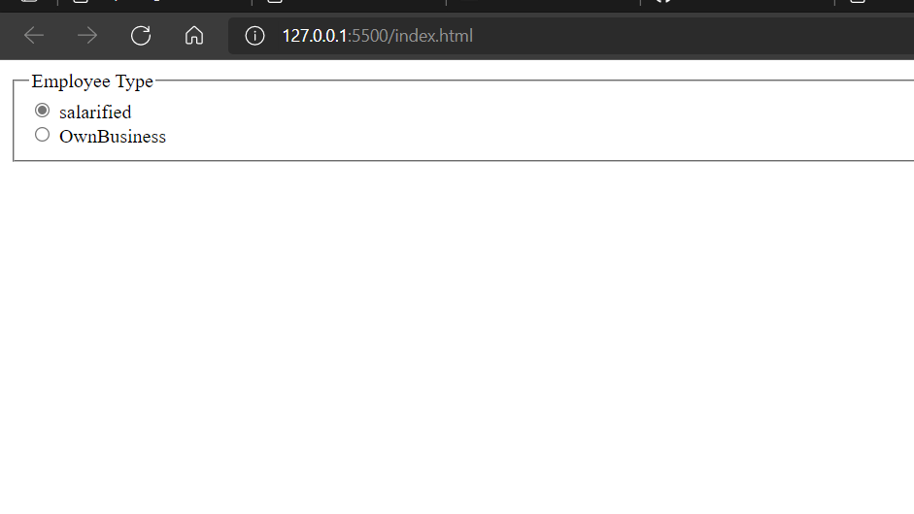

**7. Design form shown in the link**

**(http://evc**  
**cit.info/cit040/formguide/card_0.png)**

<!DOCTYPE html>

<html lang="en">

<head>

<meta charset="UTF-8">

<title>Table</title>

<style>

p{

background-color: red;

color: white;

text-align: center;

font-size: 20px;

height:25px;

}

fieldset{

border: 5px solid black;

width: 30%;

}

input{

border: none;

border-bottom: 2px solid black;

}

</style>

</head>

<body>

<form>

<fieldset>

<p>Yes! I want to subscribe to <b><i>Mag-O-Zine</i></b

></p>

<table>

<tr>

<td colspan="3">

<input type="text" id="firstname" name="first

name" size="22">

<label for="firstname" style="display:block; t

ext-align:left">First Name</label>

</td>

<td colspan="3">

<input type="text" id="lastname" name="lastnam

e" size="25">

<label for="lastname" style="display:block; te

xt-align:left">Last Name</label>

</td>

</tr>

<tr>

<td colspan="6">

<input type="text" id="address" name="add

ress" size="50" >

<label for="address" style="display:block;

text-align:left">Address </label>

</td>

</tr>

<tr>

<td colspan="2">

<input type="text" id="city" name="city"

size="10">

<label for="city style="display:block; tex

t-align:left">City</label>

</td>

<td colspan="2">

<input type="text" id="state" name="state

" size="10">

<label for="state" style="display:block; t

ext-align:left">State</label>

</td>

<td colspan="2">

<input type="text" id="zip" name="zip" siz

e="10">

<label for="zip" style="display:block; tex

t-align:left">Zip</label>

</td>

</tr>

</table>

<br>Subscribe for:

<input type="checkbox">1 year ($19.95)

<input type="checkbox">2 year ($35.00)<br>

Send me more information about:<br>

<input type="checkbox">Computer-Zine<br>

<input type="checkbox">Fishing -Zine<br>

<input type="checkbox">Cat-O-Zine

</br>

</fieldset>

</form>

</body>

</html>

Output:

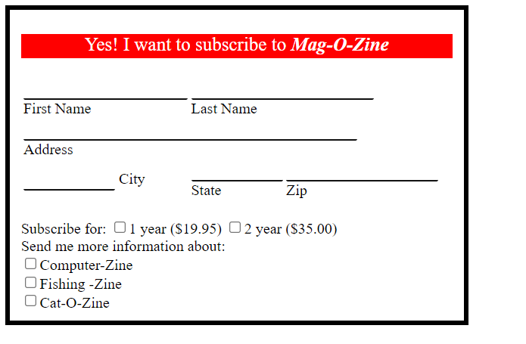

**8.Use the table tag to design given image Click here.**

<!DOCTYPE html>

<html lang="en">

<head>

<meta charset="UTF-8">

<meta http-equiv="X-UA-Compatible" content="IE=edge">

<meta name="viewport" content="width=device-width, initialscale=1.0">

<title>table</title>

<style>

h{

font-size:28px;

font-weight:bold;

font-size: larger;

position:centre;

}

table,th,td{

border: 1px solid black ;

border-collapse:collapse

}

</style>

</head>

<body>

<h>Health Cart</h>

<table>

<thead>

<tr><th rowspan="2">state of health</th><th colspan="2">Fasting value</th><th>After remaining</th></tr>

<tr><th>minimum</th><th>maximum</th><th>2 hours of eating</th></tr>

</thead>

<tbody>

|  |  |
| --- | --- |
| <tr><td>Healthy</td><td>70</td><td>100</td><td>less | than |
| 140</td></tr> |

<tr><td>Pre-Diabetis</td><td>101</td><td>126</td><td>140 to 200</td></tr>

|  |  |  |
| --- | --- | --- |
| <tr><td>Diabetis</td><td>More | than | 126</td><td>Not |
| Applicable</td><td>More than 200</td> |

</tr>

</table>

</tbody>

</body>

</html>

OUTPUT:

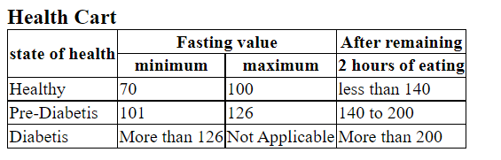

**9.. Write HTML input tags snippet to show default values for all Form elements.**

<!DOCTYPE html>

<html lang="en">

<head>

<meta charset="UTF-8">

<meta http-equiv="X-UA-Compatible" content="IE=edge">

|  |  |  |  |
| --- | --- | --- | --- |
| <meta | name="viewport" | content="width=device-width, | initial- |
| scale=1. |

0">

<title>Input Tags</title>

</head>

<body>

<p>Button : <input type="button" value="Button 1"></p>

<p>Search : <input type="search" value="google"></p>

<p>Submit : <input type="submit" value="Submit 1"></p>

<p>Tel : <input type="tel" value="9989784422"></p>

<p>Email : <input type="email" value="abc@gmail.com"></p>

<p>Check Box : <input type="checkbox" value="Checkbox"></p>

<p>Color : <input type="color" value="blue"></p>

<p>Date : <input type="date" value="2021-08-01"></p>

|  |  |  |  |  |
| --- | --- | --- | --- | --- |
| <p>Datetime | : | <input | type="datetime" | value="2024-08-04 |
| 12:00AM"></p> | |

<p>Datetime-local : <input type="datetime-local" value="2001-07-24T

10:40"></p>

<p>Email : <input type="email" value="sai@gmail.com"></p>

<p>File : <input type="file"></p>

<p>Radio : <input type="radio" value="Radio"></p>

<p>Range : <input type="range" value="45"></p>

<p>Reset : <input type="reset" value="Reset 2"></p>

<p>File : <input type="file"></p>

<p>Hidden : <input type="hidden" value="Enter hidden"></p>

<p>Image : <input type="image" value="Image"></p>

<p>Month : <input type="month" value="2021-08"></p>

<p>Number : <input type="number" value="088"></p>

<p>Text : <input type="text" value="Enter text"></p>

<p>Time : <input type="time" value="15:00"></p>

<p>Url : <input type="url" value="www.google.com"></p>

<p>Week : <input type="week" value="2021-W08"></p>

<p>Password : <input type="password" value="Enter password"></p>

<p>Radio : <input type="radio" value="Radio"></p>

<p>Range : <input type="range" value="10"></p>

<p>Reset : <input type="reset" value="Reset 1"></p>

<p>Search : <input type="search" value="google"></p>

<p>Submit : <input type="submit" value="Submit 1"></p>

<p>Tel : <input type="tel" value="0422367890"></p>

</body>

</html>

**10.In your, HTML page add the below line and Highlight it without using any CSS.**

**"HTML & CSS is awesome"**

<!DOCTYPE html>

<html lang="en">

<head>

<meta charset="UTF-8">

<meta http-equiv="X-UA-Compatible" content="IE=edge">

<meta name="viewport" content="width=device-width, initialscale=1.0">

<title>Document</title>

</head>

<style>

body{

font-size:28px;

}

</style>

<body>

<input type="radio", id="radio" name="HTML & CSS is awesome">"HTML & CSS is awesome"<br>

</body>

</html>

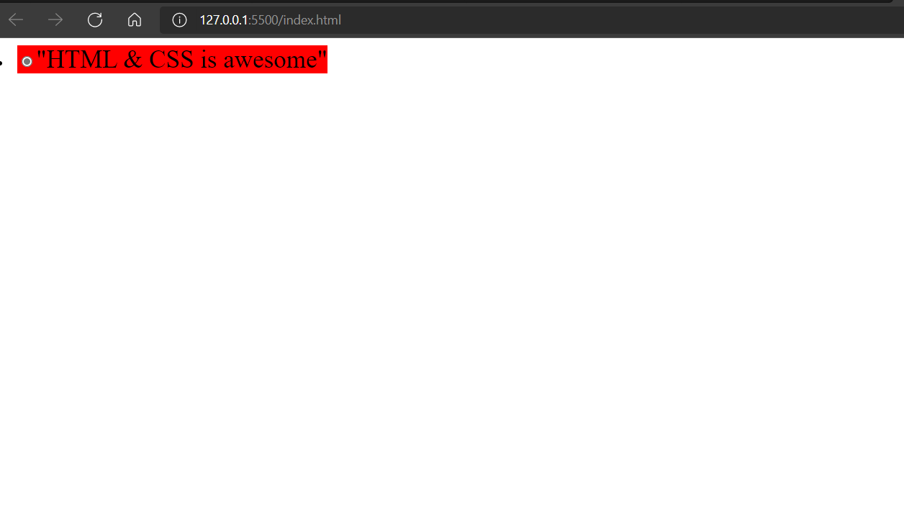

**11.Create an HTML page, which should contain all types of input elements.**

<!DOCTYPE html>

<html lang="en">

<head>

<meta charset="UTF-8">

<meta http-equiv="X-UA-Compatible" content="IE=edge">

<meta name="viewport" content="width=device-width, initial

-scale=1.0">

<title>Input Tags</title>

</head>

<body>

<p>Button : <input type="button"></p>

<p>Check Box : <input type="checkbox"></p>

<p>Color : <input type="color"></p>

<p>Week : <input type="week"></p>

<p>Url : <input type="url"></p>

<p>Week : <input type="week"></p>

<p>Month : <input type="month"></p>

<p>Number : <input type="number"></p>

<p>Password : <input type="password"></p>

<p>Date : <input type="date"></p>

<p>Datetime : <input type="datetime"></p>

<p>Datetime-local : <input type="datetime-local"></p>

<p>Email : <input type="email"></p>

<p>File : <input type="file"></p>

<p>Hidden : <input type="hidden"></p>

<p>Image : <input type="image"></p>

<p>Text : <input type="text"></p>

<p>Time : <input type="time"></p>

<p>Tel : <input type="tel"></p>

<p>Text : <input type="text"></p>

<p>Time : <input type="time"></p>

<p>Url : <input type="url"></p>

<p>Radio : <input type="radio"></p>

<p>Range : <input type="range"></p>

<p>Reset : <input type="reset"></p>

<p>Search : <input type="search"></p>

<p>Submit : <input type="submit"></p>

</body>

</html>